COMMISSIONED OFFICER RANK

2nd Lieutenant
2LT
1st Lieutenant  1LT | 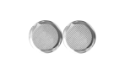
Captain  CPT | 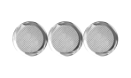
Major
MAJ
Lieutenant Colonel
LTC
Colonel
COL

NON-COMMISSIONED OFFICER RANK

Private
PVT
Private First Class
PFC
Corporal  CPL | 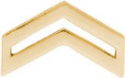
Sergeant  SGT | 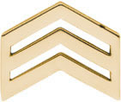
Staff Sergeant
SSG
Sergeant First Class  SFC | 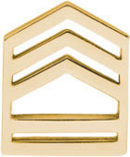
Master Sergeant  MSG | 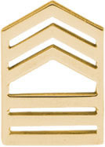
First Sergeant  1SG | 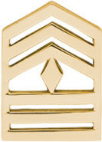
Sergeant Major  SGM | 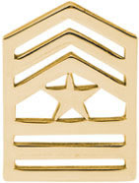
Command Sergeant Major
CSM

